How A Photovoltic Cell Works

Return Photovoltaics
The "photovoltaic effect" is the basic physical process through which a PV cell converts sunlight into electricity. Sunlight is composed of photons, or particles of solar energy. These photons contain various amounts of energy corresponding to the different wavelengths of the solar spectrum. When photons strike a PV cell, they may be reflected or absorbed, or they may pass right through. Only the absorbed photons generate electricity. When this happens, the energy of the photon is transferred to an electron in an atom of the cell (which is actually a semiconductor). With its newfound energy, the electron is able to escape from its normal position associated with that atom to become part of the current in an electrical circuit. By leaving this position, the electron causes a "hole" to form. Special electrical properties of the PV cell—a built-in electric field—provide the voltage needed to drive the current through an external load (such as a light bulb).
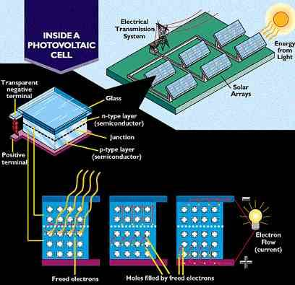
p-Types, n-Types, and the Electric Field
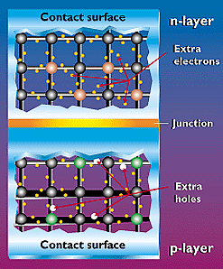
To induce the electric field within a PV cell, two separate semiconductors are sandwiched together. The "p" and "n" types of semiconductors correspond to "positive" and "negative" because of their abundance of holes or electrons (the extra electrons make an "n" type because an electron actually has a negative charge).
Although both materials are electrically neutral, n-type silicon has excess electrons and p-type silicon has excess holes. Sandwiching these together creates a p/n junction at their interface, thereby creating an electric field.
When the p-type and n-type semiconductors are sandwiched together, the excess electrons in the n-type material flow to the p-type, and the holes thereby vacated during this process flow to the n-type. (The concept of a hole moving is somewhat like looking at a bubble in a liquid. Although it's the liquid that is actually moving, it's easier to describe the motion of the bubble as it moves in the opposite direction.) Through this electron and hole flow, the two semiconductors act as a battery, creating an electric field at the surface where they meet (known as the "junction"). It's this field that causes the electrons to jump from the semiconductor out toward the surface and make them available for the electrical circuit. At this same time, the holes move in the opposite direction, toward the positive surface, where they await incoming electrons.

Making n and p Material
The most common way of making p-type or n-type silicon material is to add an element that has an extra electron or is lacking an electron. In silicon, we use a process called "doping."
We'll use silicon as an example because crystalline silicon was the semiconductor material used in the earliest successful PV devices, it's still the most widely used PV material, and, although other PV materials and designs exploit the PV effect in slightly different ways, knowing how the effect works in crystalline silicon gives us a basic understanding of how it works in all devices.
- An Atomic Description of Silicon - The Silicon Molecule
- Introducing Phosphorous - Boron - Other Semiconductor Materials

Absorption and Conduction
In a PV cell, photons are absorbed in the p layer. It's very important to "tune" this layer to the properties of the incoming photons to absorb as many as possible and thereby free as many electrons as possible. Another challenge is to keep the electrons from meeting up with holes and "recombining" with them before they can escape the cell. To do this, we design the material so that the electrons are freed as close to the junction as possible, so that the electric field can help send them through the "conduction" layer (the n layer) and out into the electric circuit. By maximizing all these characteristics, we improve the conversion efficiency* of the PV cell.
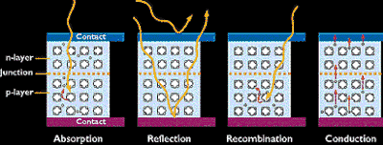
To make an efficient solar cell, we try to maximize absorption, minimize reflection and recombination, and thereby maximize conduction.
*The conversion efficiency of a PV cell is the proportion of sunlight energy that the cell converts to electrical energy. This is very important when discussing PV devices, because improving this efficiency is vital to making PV energy competitive with more traditional sources of energy (e.g., fossil fuels). Naturally, if one efficient solar panel can provide as much energy as two less-efficient panels, then the cost of that energy (not to mention the space required) will be reduced. For comparison, the earliest PV devices converted about 1%-2% of sunlight energy into electric energy. Today's PV devices convert 7%-17% of light energy into electric energy. Of course, the other side of the equation is the money it costs to manufacture the PV devices. This has been improved over the years as well. In fact, today's PV systems produce electricity at a fraction of the cost of early PV systems.

A typical silicon PV cell is composed of a thin wafer consisting of an ultra-thin layer of phosphorus-doped (N-type) silicon on top of a thicker layer of boron-doped (P-type) silicon. An electrical field is created near the top surface of the cell where these two materials are in contact, called the P-N junction. When sunlight strikes the surface of a PV cell, this electrical field provides momentum and direction to light-stimulated electrons, resulting in a flow of current when the solar cell is connected to an electrical load
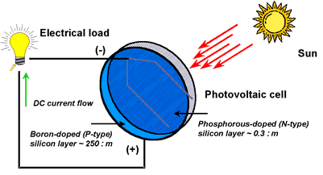
Figure 1. Diagram of a photovoltaic cell.
Regardless of size, a typical silicon PV cell produces about 0.5 – 0.6 volt DC under open-circuit, no-load conditions. The current (and power) output of a PV cell depends on its efficiency and size (surface area), and is proportional to the intensity of sunlight striking the surface of the cell. For example, under peak sunlight conditions, a typical commercial PV cell with a surface area of 160 cm^2 (~25 in^2) will produce about 2 watts peak power. If the sunlight intensity were 40 percent of peak, this cell would produce about 0.8 watts.

Photovoltaic cells are connected electrically in series and/or parallel circuits to produce higher voltages, currents and power levels. Photovoltaic modules consist of PV cell circuits sealed in an environmentally protective laminate, and are the fundamental building blocks of PV systems. Photovoltaic panels include one or more PV modules assembled as a pre-wired, field-installable unit. A photovoltaic array is the complete power-generating unit, consisting of any number of PV modules and panels.
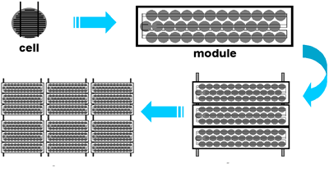
Figure 1. Photovoltaic cells, modules, panels and arrays.
The performance of PV modules and arrays are generally rated according to their maximum DC power output (watts) under Standard Test Conditions (STC). Standard Test Conditions are defined by a module (cell) operating temperature of 25o C (77o F), and incident solar irradiance level of 1000 W/m2 and under Air Mass 1.5 spectral distribution. Since these conditions are not always typical of how PV modules and arrays operate in the field, actual performance is usually 85 to 90 percent of the STC rating.
Today’s photovoltaic modules are extremely safe and reliable products, with minimal failure rates and projected service lifetimes of 20 to 30 years. Most major manufacturers offer warranties of 20 or more years for maintaining a high percentage of initial rated power output. When selecting PV modules, look for the product listing (UL), qualification testing and warranty information in the module manufacturer’s specifications.

Simply put, PV systems are like any other electrical power generating systems, just the equipment used is different than that used for conventional electromechanical generating systems. However, the principles of operation and interfacing with other electrical systems remain the same, and are guided by a well-established body of electrical codes and standards.
Although a PV array produces power when exposed to sunlight, a number of other components are required to properly conduct, control, convert, distribute, and store the energy produced by the array.
Depending on the functional and operational requirements of the system, the specific components required may include major components such as a DC-AC power inverter, battery bank, system and battery controller, auxiliary energy sources and sometimes the specified electrical load (appliances). In addition, an assortment of balance of system (BOS) hardware, including wiring, overcurrent, surge protection and disconnect devices, and other power processing equipment. Figure 3 show a basic diagram of a photovoltaic system and the relationship of individual components.
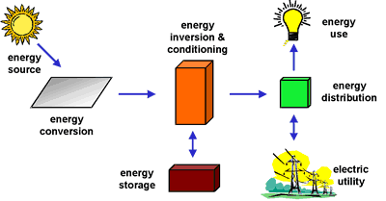
Figure 1. Major photovoltaic system components.
Why Are Batteries Used in Some PV Systems?
Batteries are often used in PV systems for the purpose of storing energy produced by the PV array during the day, and to supply it to electrical loads as needed (during the night and periods of cloudy weather). Other reasons batteries are used in PV systems are to operate the PV array near its maximum power point, to power electrical loads at stable voltages, and to supply surge currents to electrical loads and inverters. In most cases, a battery charge controller is used in these systems to protect the battery from overcharge and overdischarge.

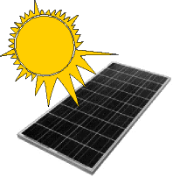
Photovoltaic (PV) Solar Panels generate electricity by the Photovoltaic Effect. Discovered in 1839 by 19 year old Edmund Becquerel, the photovoltaic effect is the phenomenon that certain materials produce electic current when they are exposed to light.

PN Junction Semiconductors
For traditional PV solar panels two halves of one pure silicon crystal are doped with two different dopants (e.g. arsenic, gallium, aluminium, phosphorus). One half of the crystal is left electron deficient - i.e. the atoms it contains are short of electrons. This is called the p-type layer. The other half of the crystal has an excess of electrons - this is called the n-type layer.
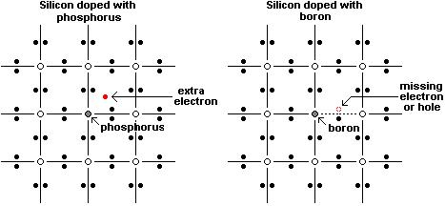
Since one half of the crystal has a lot of electrons, and the other half does not, there is an electric field across the junction between the two halves. Electrons in the crystal can only travel in one direction - from the electron rich half to the electron poor half.
Where the two halves of the crystal meet is called a PN junction, and this doped crystal is a semiconductor. (Click here to read our article How are Solar Panels Made in which the solar panel manufacturing process is presented.)
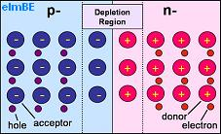
Pictured above is a representation of PN junction semiconductor. The half labelled p- has a shortage of electrons so contains acceptor atoms each with a hole which could be 'filled' by an electron. The half labelled n- has excess electrons and so contains donor atoms which have an extra electron.

The Depletion Region
Where the two halves of the crystal meet, there is a depletion region, so called because it is depleted of charge carriers (the electrons and holes). Here electrons have moved from the n-type (negative) side to the p-type (positive) side of the crystal recombining with holes. Likewise holes have moved from the p-type side to the n-type side.
As the silicon atoms themselves do not move, any holes which remain uncovered by electrons in the n-type side are left positively charged, and any electrons without holes to cover in the p-type side remain negatively charged. This leaves positive material close to the junction in the n-type side, and negative material close to the junction in the p-type side with a potential between the two sides of around 0.6-0.7 volts in a silicon PN junction.
With this equilibrium position reached there are two equal and opposite electric currents flowing - holes in one direction and electrons in the other direction - across the depletion region.

Energy from Sunlight
The light from the sun is made up of packets of energy called Photons. Each photon carries an amount of energy corresponding to its wavelength of light.
When a visible light photon strikes a solar cell it can do one of three things: pass straight through, be reflected, or be absorbed. If the photon is absorbed, its energy is absorbed by an electron in an atom of the solar cell enabling it to escape from its normal position (photon excitation), cross the junction and fill a hole. Since electrons are physically moving across the PN junction, the positive charge carrying holes are effectively moving in the opposite direction around the load circuit (a rechargeable battery or light bulb etc). This completes the circuit providing more holes for the electrons to combine with and providing usable electricity.
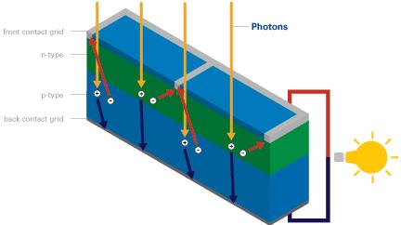
Energy from the sun can be extracted in this way using a standard solar cell at an efficiency of around 5-15% (see our article 40% Efficiency Solar Panels for details on how more efficient solar cells can be made). This process can be repeated over and over again over the many decades of usable lifetime of solar cells.

